DR. B.R. AMBEDKAR NATIONAL

INSTITUTE OF TECHNOLOGY

JALANDHAR-144011, PUNJAB (INDIA)

**COMPUTER SCIENCE AND ENGINEERING**

DATA BASE MANAGEMENT SYSTEM

(CSX-224)



JAN-JUN 2017

LAB PRACTICALS RECORD

SUBMITED BY-RAKESH BAKOLIA SUBMITED TO- Ms. KRITI

ROLL NO. -15103042 ASST. PROFESSOR

CSE DEPT. OF CSE

**INDEX**

|  |  |  |
| --- | --- | --- |
|  | TITLE | DATE |
| 1.  2. | Installing Oracle Database 12c on Windows  Create Tables using SQL commands assign datatypes and perform operations | 11-01-17 |

**Installing Oracle Database 12c on Windows**

**Overview**

Purpose

This tutorial shows you how to install the Oracle Database 12*c* software on Microsoft Windows along with a default

instance of an Oracle Database that contains example schemas ( including the HR schema).

Time to Complete

Approximately 1 hour.

Introduction

The Oracle Universal Installer (OUI) is used to install the Oracle Database software. OUI is a graphical user interface

utility that enables you to:

View the Oracle software that is installed on your machine

Install new Oracle Database software

Delete Oracle software that is no longer required

During the installation process, OUI will start the Oracle Database Configuration Assistant (DBCA) which can install a

precreated default database that contains example schemas or can guide you through the process of creating and

configuring a customized database.

If you do not create a database during installation, you can invoke DBCA after you have installed the software, to create

one or more databases.

Hardware and Software Requirements

Before installing the software, OUI performs several automated checks to ensure that your computer fulfills the basic

hardware and software requirements for an Oracle Database installation. If your computer does not meet the

requirements, an error message is displayed. Some of the requirements to install the software are:

Minimum 2 GB of physical memory

Sufficient virtual memory (swap)

At least 10 GB of free disk space

Prerequisites

Before starting this tutorial, you should:

Have access to the Oracle Database 12c distribution media, or have an internet connection so that you can

download the software

Have general knowledge of product installation

Downloading the Oracle Database Software

In this section, you will be downloading the files required to install Oracle database on a Windows environment.

1. Open a web browser of your choice and navigate to http://otn.oracle.com/windows. By default, the page

displays the What's New tab, showcasing news about Oracle on Windows.

Note: In this OBE, we use Internet Explorer to download the software.

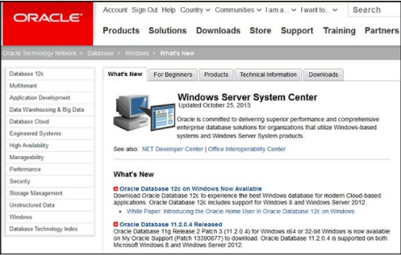

2. Click the Downloads tab

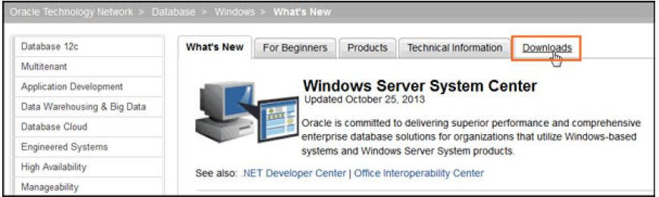

3. Click on the latest version of Oracle Database 12c (x64).

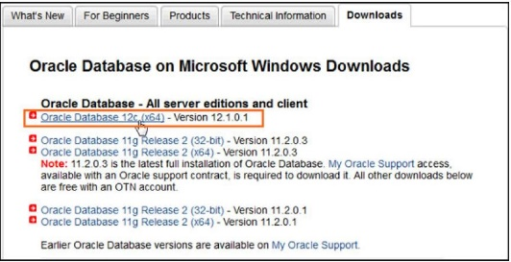

4. The software downloads page displays the files required to download the database. It lists a set of software

files to install software such as, Oracle Database Grid Infrastructure and Oracle Database Gateways with the Oracle database. Each set displays a short description of what the file includes. You can choose to

download any set of software depending on your requirement.

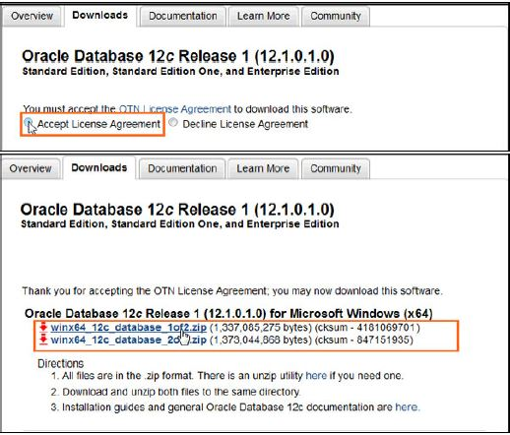

5.Log into your Oracle web account. If you do not have an Oracle account, click the "Sign Up" link to create

one. Then choose the location where you want to download the .zip files.

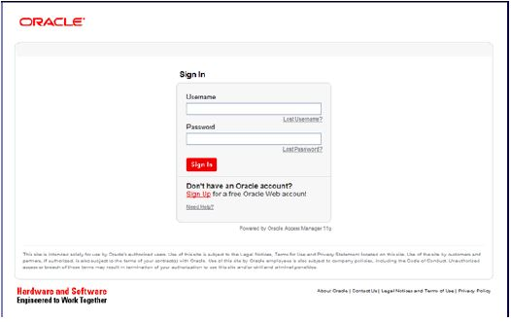

6. After downloading the files, use the default builtin extraction tool provided by Windows, or tools such as 7zip

to extract the .zip files. In this OBE, we use the builtin extractor to extract the software files

Right click winx64_12c_database_1of2 and select Extract All...

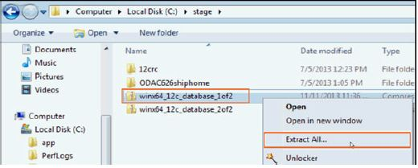

7.The software files are extracted. Expand the winx64_12c_database_1 folder.

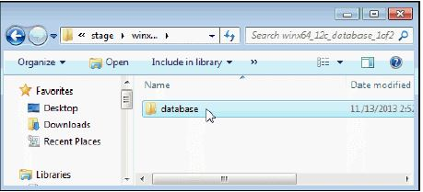

Installing the Oracle Database Software

In this section, you will be installing the Oracle Database and creating an Oracle Home User account.

1. Expand the database folder that you extracted in the previous section. Doubleclick

setup.

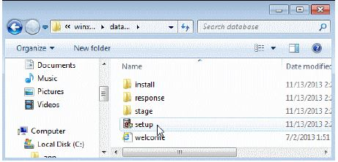

2. Click Yes in the User Account Control window to continue with the installation.

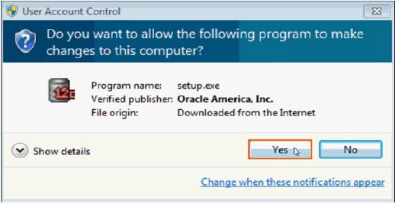

3. The Download Software Updates window appears with the following options:

Select "Use My Oracle Support credentials for download" to download and apply the latest software updates.

Select "Use predownloaded

software updates" to apply software updates that you previously

downloaded.

Select "Skip software updates" if do not want to apply any updates

Accept the default and click Next.

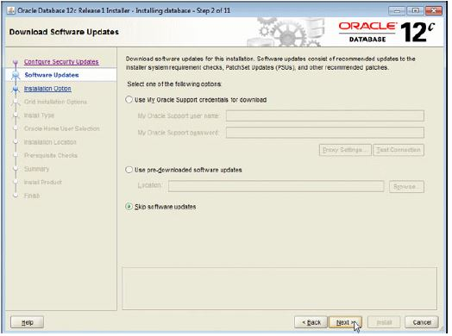

4.The Select Installation Option window appears with the following options:

Select "Create and configure a database" to install the database, create database instance and

configure the database.

Select "Install database software only" to only install the database software.

Select "Upgrade an existing database" to upgrade the database that is already installed.

In this OBE, we create and configure the database. Select the Create and configure a database option and

click Next.

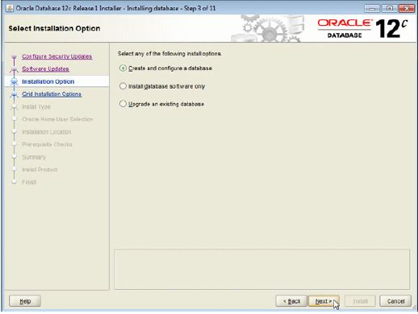

5. The System Class window appears. Select Desktop Class or Server Class depending on the type of system

you are using. In this OBE, we will perform the installation on a desktop/laptop. Select Desktop class and

click Next.

6.The Oracle Home User Selection window appears. Starting with Oracle Database 12c Release 1 (12.1),

Oracle Database on Microsoft Windows supports the use of an Oracle Home User, specified at the time of

installation. This Oracle Home User is used to run the Windows services for a Oracle Home, and is similar to

the Oracle User on Oracle Database on Linux. This user is associated with an Oracle Home and cannot be

changed to a different user post installation.

Note:

Different Oracle homes on a system can share the same Oracle Home User or use different Oracle

Home Users.

The Oracle Home User is different from an Oracle Installation User. The Oracle Installation User is the

user who requires administrative privileges to install Oracle products. The Oracle Home User is used

to run the Windows services for the Oracle Home.

The window provides the following options:

If you select "Use Existing Windows User", the user credentials provided must be a standard Windows

user account (not an administrator).

If this is a single instance database installation, the user can be a local user, a domain user, or

a managed services account.

If this is an Oracle RAC database installation, the existing user must be a Windows domain

user. The Oracle installer will display an error if this user has administrator privileges.

If you select "Create New Windows User", the Oracle installer will create a new standard Windows

user account. This user will be assigned as the Oracle Home User. Please note that this user will not

have login privileges. This option is not available for an Oracle RAC Database installation.

If you select "Use Windows Builtin

Account", the system uses the Windows Builtin

account as the

Oracle Home User.

Select the Create New Windows User option. Enter the user name as OracleHomeUser1 and password as

Welcome1. Click Next.

Note: Remember the Windows User password. It will be required later to administer or manage database

services.

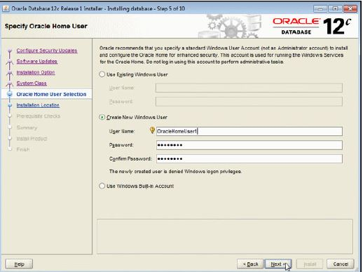

7. The Typical Install Configuration window appears. Click on a text field and then the balloon icon ( )to

know more about the field. Note that by default, the installer creates a container database along with a

pluggable database called "pdborcl". The pluggable database contains the sample HR schema. Change the

Global database name to orcl. Enter the "Administrative password" as Oracle_1. This password will be

used later to log into administrator accounts such as SYS and SYSTEM. Click Next.

8. The prerequisite checks are performed and a Summary window appears. Review the settings and click

Install.

Note: Depending on your firewall settings, you may need to grant permissions to allow java to access the

network.

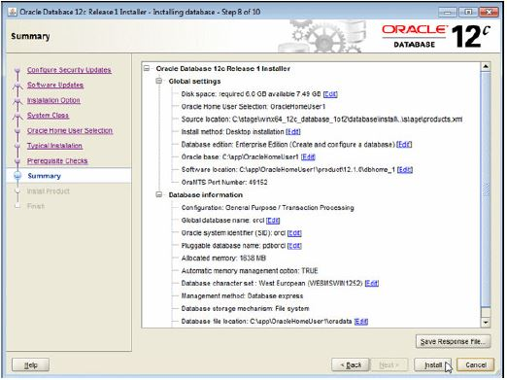

9. The progress window appears.

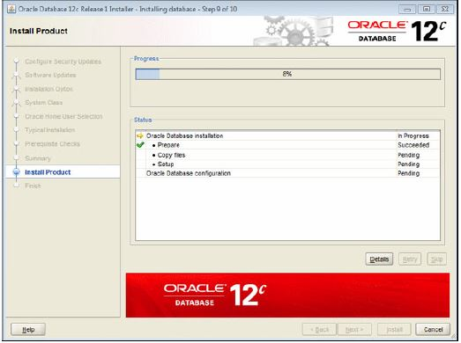

10. The Database Configuration Assistant creates the database.

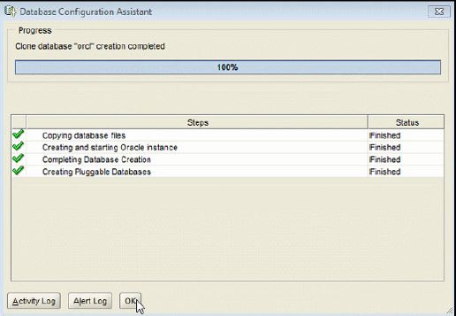

11. After the Database Configuration Assistant creates the database, you can navigate to

https://localhost:5500/em as a SYS user to manage the database using Enterprise Manager Database

Express. You can click "Password Management..." to unlock accounts. Click OK to continue

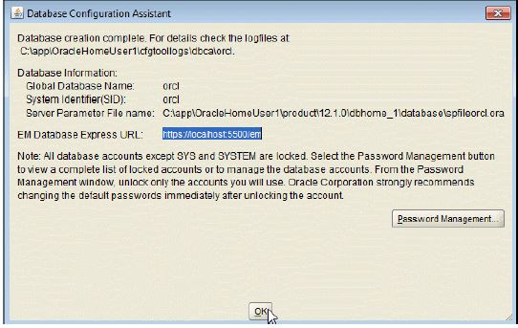

12. The Finish window appears. Click Close to exit the Oracle Universal Installer.

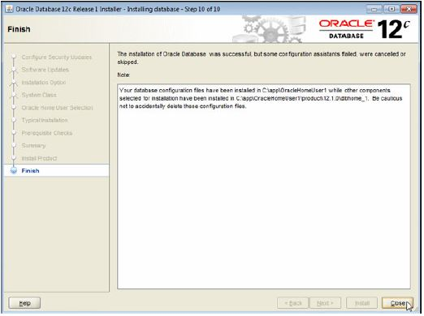

Aim:- Create Tables using SQL commands assign datatypes and perform operations

1. Creation of Table

Create Table Rakesh1 (Names char(20),RollNo int,Branch char(20),Gender char(8),City char(20)

Table is created

2. Insertion In table.

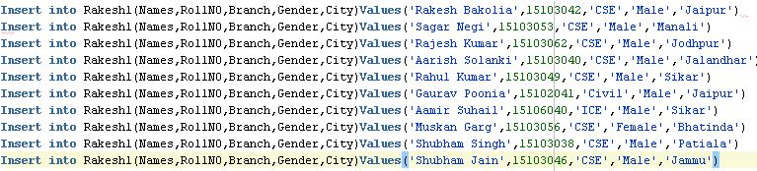

Select * from Rakesh1

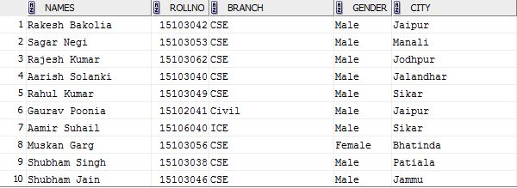

Queries:-

Q1. Retrieve Data from Table where city must be Jalandhar and RollNo must be 10103015.



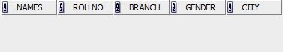

Q2. Retrieve Data from Table where City must be Jalandhar or RollNo must be 15103015.





Q3. Select data from table where RollNo not greater than 15103025.





Q4. Retrieve Name From the table where city is Jalandhar and RollNo is 25 and Age must be greater than 15103010.





Q5.

Q6. Retrieve Age from table where city is other than Jalandhar and RollNo must be 15103042.





Q7. Retrieve Data from table where city is other than Jalandhar and Age must be greater than 15 and RollNo must be other than 15103018.



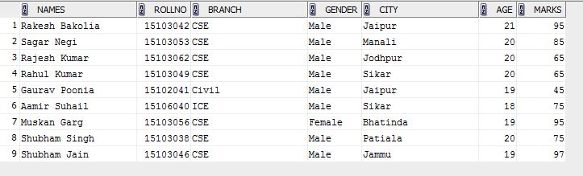Q8. Retrieve data from table where city is other than Jalandhar and Age must be greater than 15 and RollNo must be equal to other than 15103018.



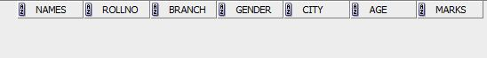

Q9. Retrieve data from table where city is other than Jalandhar and Age must be greater than 15 and RollNo must be greater than 15103018.



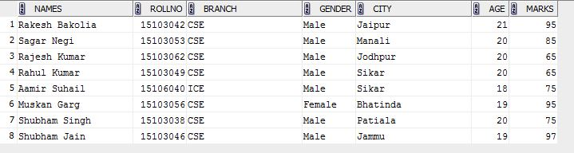

Q10. Retrieve data from table where city is other than Jalandhar and Age must be greater than 15 and RollNo must be other than 15103021.



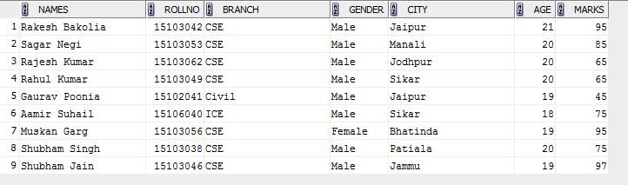

3. between and In Operator

Q11. Retrieve RollNo Name City Age from Table where the age is between 15103040 and 15103053.



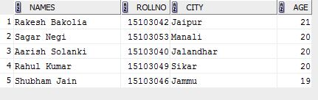

Q12. Retrieve RollNo Name City Age from Table where the age is not between 15103040 and 15103053.



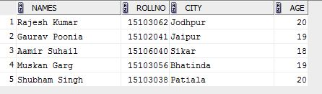

4. Pattern Matching

Q13. Retrieve Name from the Table where Names begin with the later Ra.



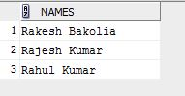

Q14. Retrieve all information about the table where second character of names is a.



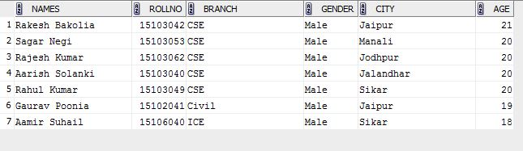

Q15. Retrieve RollNo Names city from the table where city either Jaipur or Chandigarh or Jalandhar.



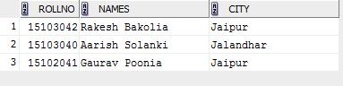

Q16. Retrieve RollNo Name City from the table where city either Bombay nor Chandigarh nor Jalandhar.



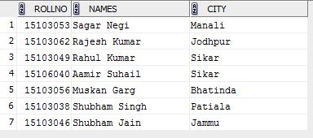

5. Aggregates Function

Q17. Select Avg. Marks from Table.





Q18. Select Sum of marks from Table.





Q19. Find Minimum of marks from Table.





Q20. Find the maximum of marks from Table.





Q21. Find the count of the table.





Q22. Count Name from Table where branch is CSE.





6. Numeric Numbers

Q23. Find the absolute of -15 using dual.





Q24. Find the Square root of 16 using dual.





Q25. Find the power of any number using dual.





Q26. Do a Round-of of a floating number.





7. String Functions.

(A) LOWER



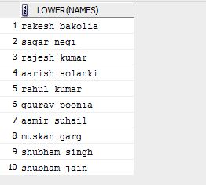

(B) UPPER



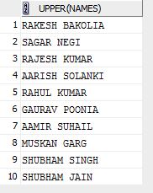

(C) INITCAP



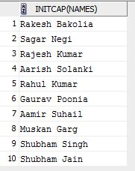

(D) LENGTH



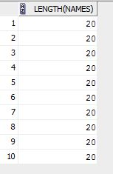

(E) LTRIM



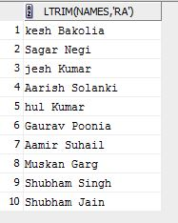

(F) RTRIM



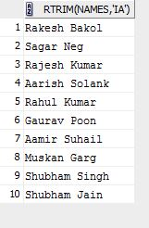

(G) LPAD



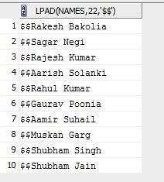

(H) RPAD



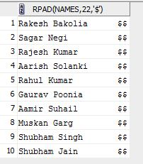

(I)SUBSTR



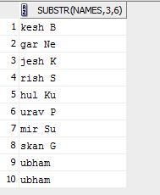

**PRIMARY KEY:**

**TYPE_1:**

**SYNTAX:** CREATE TABLE tablename (Column 1 datatype(size) primary key,Column 2 datatype(size). . . . . .);

**EXAMPLE:** create table employees (emp_id int primary key,name varchar(20),designation varchar(30))

insert into employees (emp_id,name,designation) values (123,'puneet','manager')

select * from employees

keyinsert.JPG

insert into employees (emp_id,name,designation) values (123,'nikhil','submanager')

violet.JPG

insert into employees (emp_id,name,designation) values (124,NULL,'submanager')

select * from employees

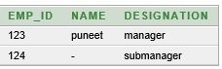

insert into employees (emp_id,name,designation) values (NULL,'nikhil','submanager')

nullpri.JPG

**TYPE_2:**form any primary key after declare all the attributes

**SYNTAX:** CREATE TABLE tablename (Column 1 datatype(size) ,Column 2 datatype(size). . . . . .,constraint xyz primary key(attribute_name)/primary key(attribute_name));

**EXAMPLE:** create table employees_1 (emp_id int ,name varchar(20),designation varchar(30),constraint xyz primary key(emp_id))

123.JPG

**TYPE_3:**make primary key of previously exist table

**SYNTAX:** alter table table_name add primary key (attribute)

**EXAMPLE:** alter table student_79 add primary key (name1)

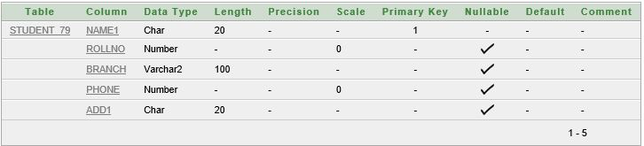

**DROP PRIMARY KEY():**

**SYNTAX:**alter table table_name drop primary key

**EXAMPLE:** alter table student_79 drop primary key

dropprimary.JPG

**UNIQUE KEY:**

**TYPE_1:**

**SYNTAX:** CREATE TABLE tablename (Column 1 datatype(size) unique,Column 2 datatype(size) unique. . . . . .);

**EXAMPLE:** create table employees_6 (emp_id int unique,name varchar(20) unique,designation varchar(30))

insert into employees_6 (emp_id,name,designation) values (123,'puneet','manager')

select * from employees_6

keyinsert.JPG

insert into employees_6 (emp_id,name,designation) values (123,'nikhil','submanager')

violet.JPG

insert into employees_6 (emp_id,name,designation) values (124,NULL,'submanager')

select * from employees_6



insert into employees_6 (emp_id,name,designation) values (null,'anshul','submanager')

select * from employees_6

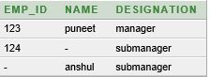

**TYPE_2:**form any unique key after declare all the attributes

**SYNTAX:** CREATE TABLE tablename (Column 1 datatype(size) ,Column 2 datatype(size). . . . . .,constraint xyz unique(attribute_name)/unique(attribute_name));

**EXAMPLE:** create table employees_7 (emp_id int ,name varchar(20),designation varchar(30),cons123.JPGtraint asd unique(emp_id)/unique(emp_id))

**TYPE_3:**make unique key of previously exist table

**SYNTAX:** alter table table_name add unique(attribute)

**EXAMPLE:** alter table student_79 add unique (name1)

ater.JPG

**DROP UNIQUE KEY():**

**SYNTAX:**alter table table_name drop unique (unique_key _name)

**EXAMPLE:** alter table student_79 drop unique(name1)

dropprimary.JPG

**FOREIGN_KEY():**

**TYPE_1:**

**SYNTAX:** CREATE TABLE child_tablename (Column 1 datatype(size) primary key,Column 2 datatype(size). . . . . .,foreign key (column_name),references parent_table_anme);

**EXAMPLE:** create table employees (emp_id int primary key,name varchar(20),designation varchar(30))